Banking Data Engineering Project – Full Synopsis (Day-1 → Day-5)
End-to-End Azure Modern Data Platform
1. Introduction
Banks generate massive volumes of data from ATMs, UPI, mobile banking, branches, and core systems.
To modernize operations, they require:
- Real-time fraud detection
- Unified Customer-360 profile
- Secure, scalable data storage
- Automated CI/CD for quick deployments
- Reporting for business + regulatory needs
This 5-day project builds a modern banking data platform using:
Azure Functions, Event Grid, Service Bus, Blob Storage, ADLS Gen2, Cosmos DB, Azure SQL, PySpark, Power BI, CI/CD, Networking (Firewall).
2. Project Objectives:
Area | Objective
Data Ingestion | Collect ATM/UPI/Customer/Core banking data in real-time + batch
Data Transformation | Clean, validate, merge, dedupe, standardize using PySpark
Operational Store | Build Cosmos DB for real-time lookups
Data Warehouse | Build dimensions & fact tables for analytics
Real-Time Alerts | Trigger fraud alerts using Event Grid & Functions
Security | Protect resources with VNet + Firewall
CI/CD | Auto-build & deploy Azure Functions, ETL, SQL

DAY-1 — Data Architecture + Ingestion Layer Setup
What to do:
- Design complete cloud architecture
- Create storage layers (raw → bronze → silver → gold)
- Enable real-time ingestion via Event Grid
- Create Azure Function (Event Grid Trigger)
- Build queue-based flow for scalable processing
Azure Part-A (Portal Tasks)
1. Create ADLS Gen2
- Storage Account → Enable Hierarchical Namespace
- Create Containers:
  - raw/atm
  - raw/upi
  - raw/customer
  - raw/master
2. Create Event Grid Subscription
- Event Source → Storage Blob
- Event Type → “Blob Created”
- Endpoint → Function App (EventGrid Trigger)
3. Create Storage Queue
- ingestion-queue
4. Create Function App (Python)
- Runtime: Python 3.10
- Hosting: Consumption Plan

VS Code Part-B (Development Tasks)
Event Grid Trigger (Function-1)
Purpose:
- Detect file upload in raw folder
- Read metadata
- Push message into Storage Queue
✔ eventgrid_function.py
- Validate file
- Build message
- Queue output binding → send message

FIGURE: 1.1
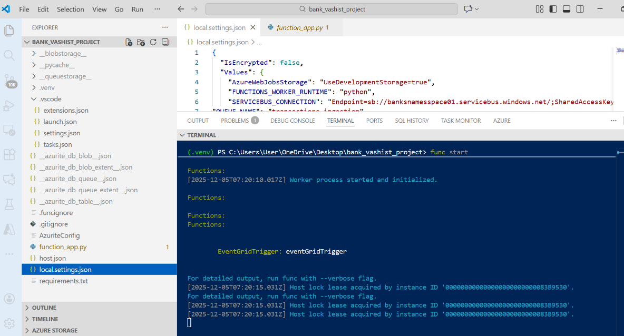

FIGURE:1.2
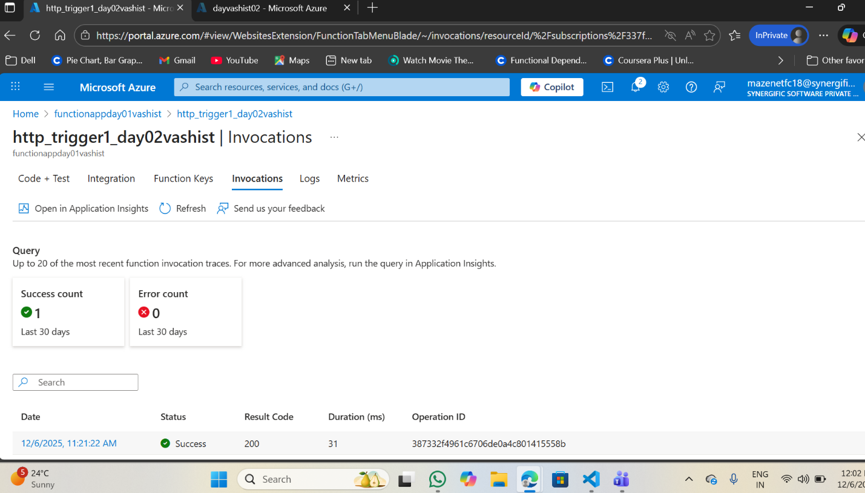

this shows you the function has successfully executed once in the last 30 da
DAY-2 — Queue Trigger, Data Cleaning, Loading into Cosmos DB
What We Do in Day-2
- Pull messages from queue
- Read file from Blob Storage
- Validate schema
- Remove duplicates
- Classify UPI/ATM
- Insert cleaned data into Cosmos DB
Azure Part-A (Portal Work)
Create Cosmos DB (Core API SQL):

Container | Purpose | Partition Key
ATMTransactions | ATM events | /TransactionID
UPIEvents | UPI debit/credit | /TransactionID
FraudAlerts | Alerts | /CustomerID

A file is uploaded
You upload a file like:
- ATM.csv
- UPI.csv
- Customer.csv
onto your raw container in Azure Storage.

# Event Grid sends a message to the Queue
Event Grid sees the new file and tells Azure:
“A new file is uploaded. Process it!”
It sends a message with:
- File name
- File path
- File type
into Azure Storage Queue.
# Queue Trigger Function automatically starts
Your Day-2 Azure Function (Function-2) is connected to the queue.
When a message arrives → this function wakes up.
Nothing manual — fully automatic.
# Function reads the file from Blob Storage
The function uses the file info from the queue to find and download the file from Blob Storage.
# Function loads the file into pandas
Pandas helps with:
- Easy data cleaning
- Easy column handling
- Faster processing
The CSV file becomes a table-like structure, just like Excel.
# Function cleans the data
- This is the most important part of Day-2.
- The data cleaning includes:
- Remove empty rows
- Remove duplicate rows
- Fix date/time formats
- Convert amount column into numbers
- Normalize column names
- Remove unwanted characters (₹, commas, spaces)
- Validate required columns exist
- Detect missing or invalid values
By this step, your raw data becomes clean, correct, and ready for analytics.

# Convert the clean data to JSON
Cosmos DB requires JSON format.
Each row in the CSV becomes a JSON object like:
{
"TransactionID": "ATM001",
"CustomerID": "C1001",
"Amount": 5000,
"Type": "ATM",
"Location": "Delhi",
"Timestamp": "2025-12-05T11:30:00"
}

# Insert all JSON documents into Cosmos DB
Based on whether the file is ATM or UPI, the data goes into the correct container:
- ATM data → ATMTransactions
- UPI data → UPIEvents
This is your operational NoSQL store.

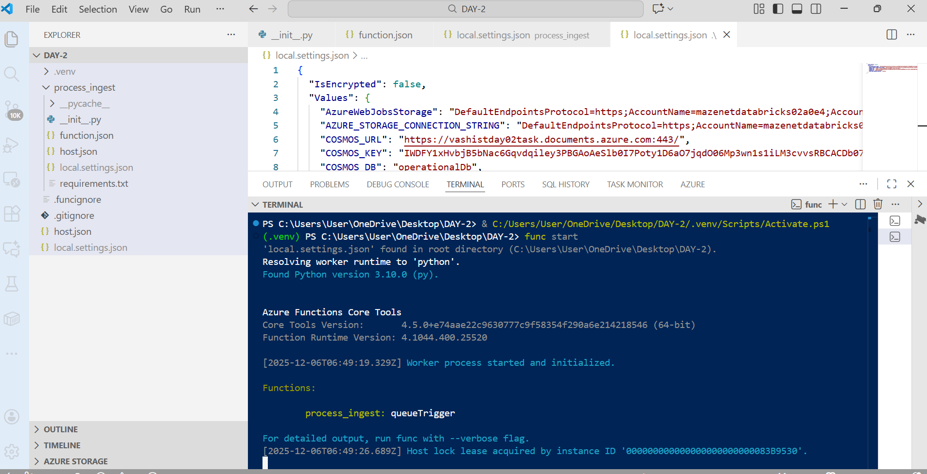
Figure :

Figure:
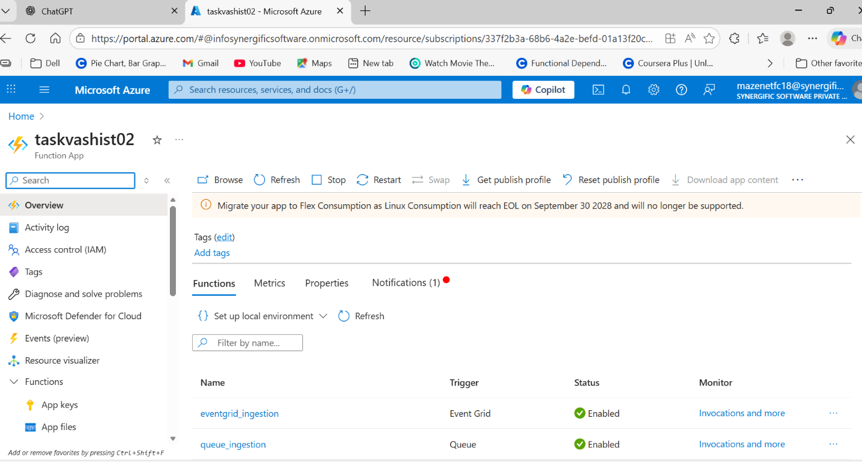

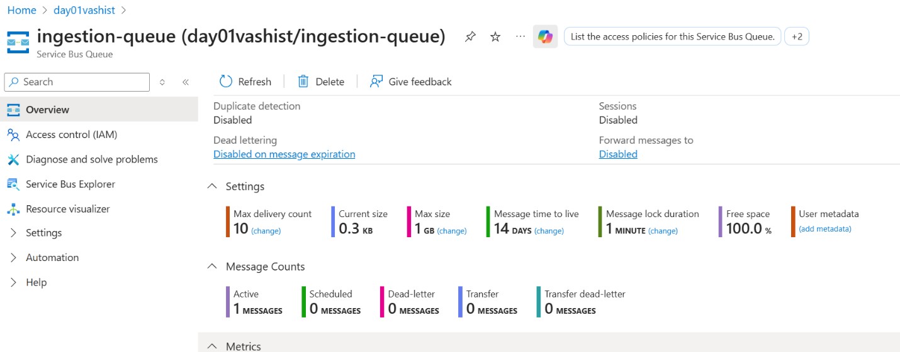
Figure:
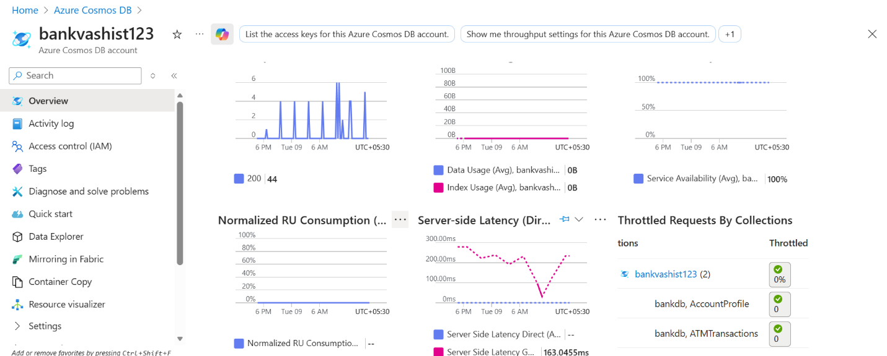
Figure:

Figure:

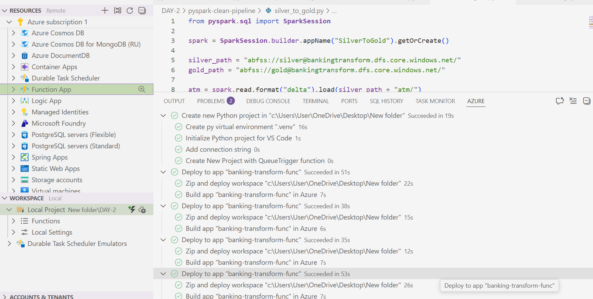

Figure:
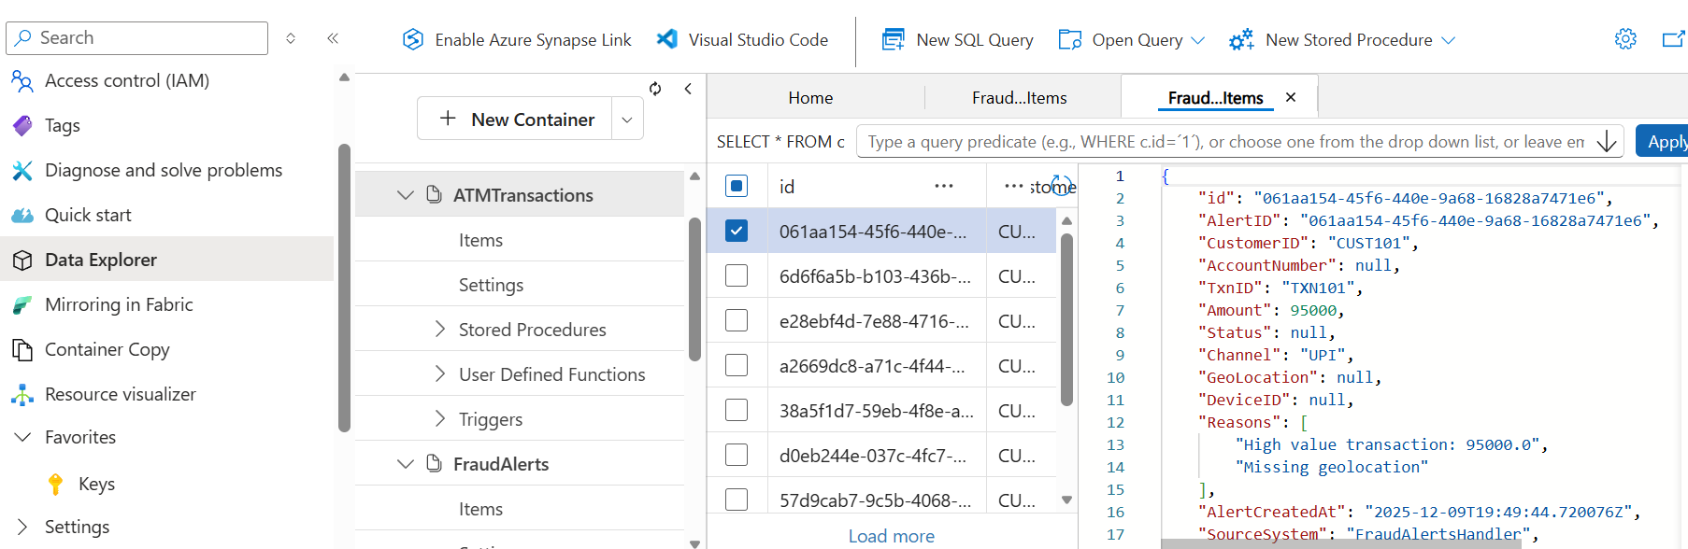

DAY-3 — Data Warehouse (Azure SQL) + ETL (PySpark)
Goal: Convert cleaned Cosmos DB data into analytics-ready SQL Warehouse tables
Simple Explanation of Day-3 Flow:
Cosmos DB (Clean Data)
↓
Spark ETL (Databricks / Synapse)
↓
Silver & Gold Layers (ADLS)
↓
Azure SQL Data Warehouse
Step-1 : Read data from Cosmos DB using PySpark
Step-2: Save this data into ADLS Bronze ---- Silver --- Gold layers
Step-3: Transform data using PySpark
  - Combine ATM + UPI data
  - Add new calculated fields
  - Fix data types
  - Prepare dimension tables
  - Prepare fact tables

Figure:
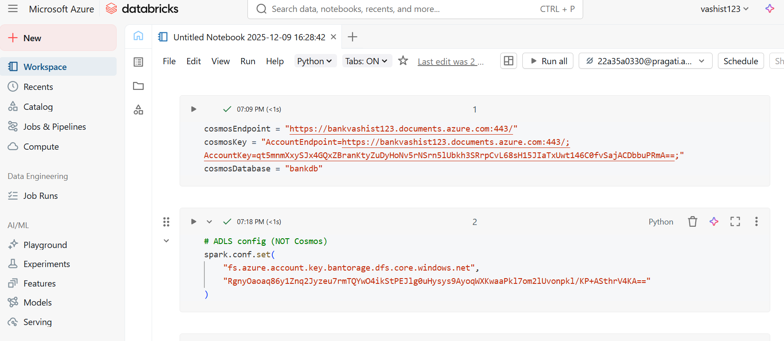
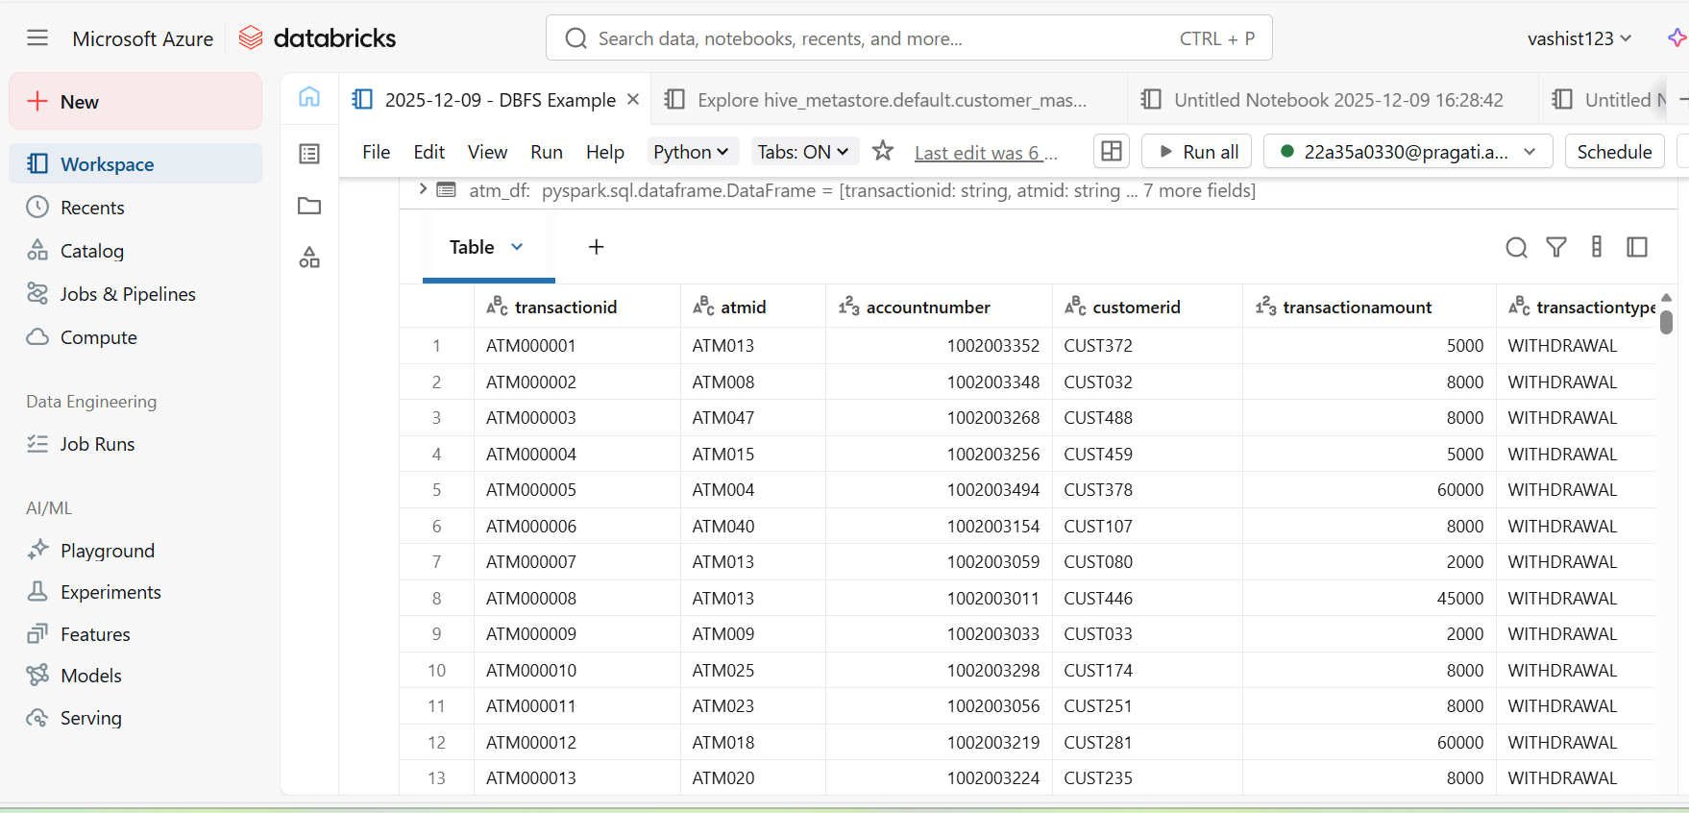
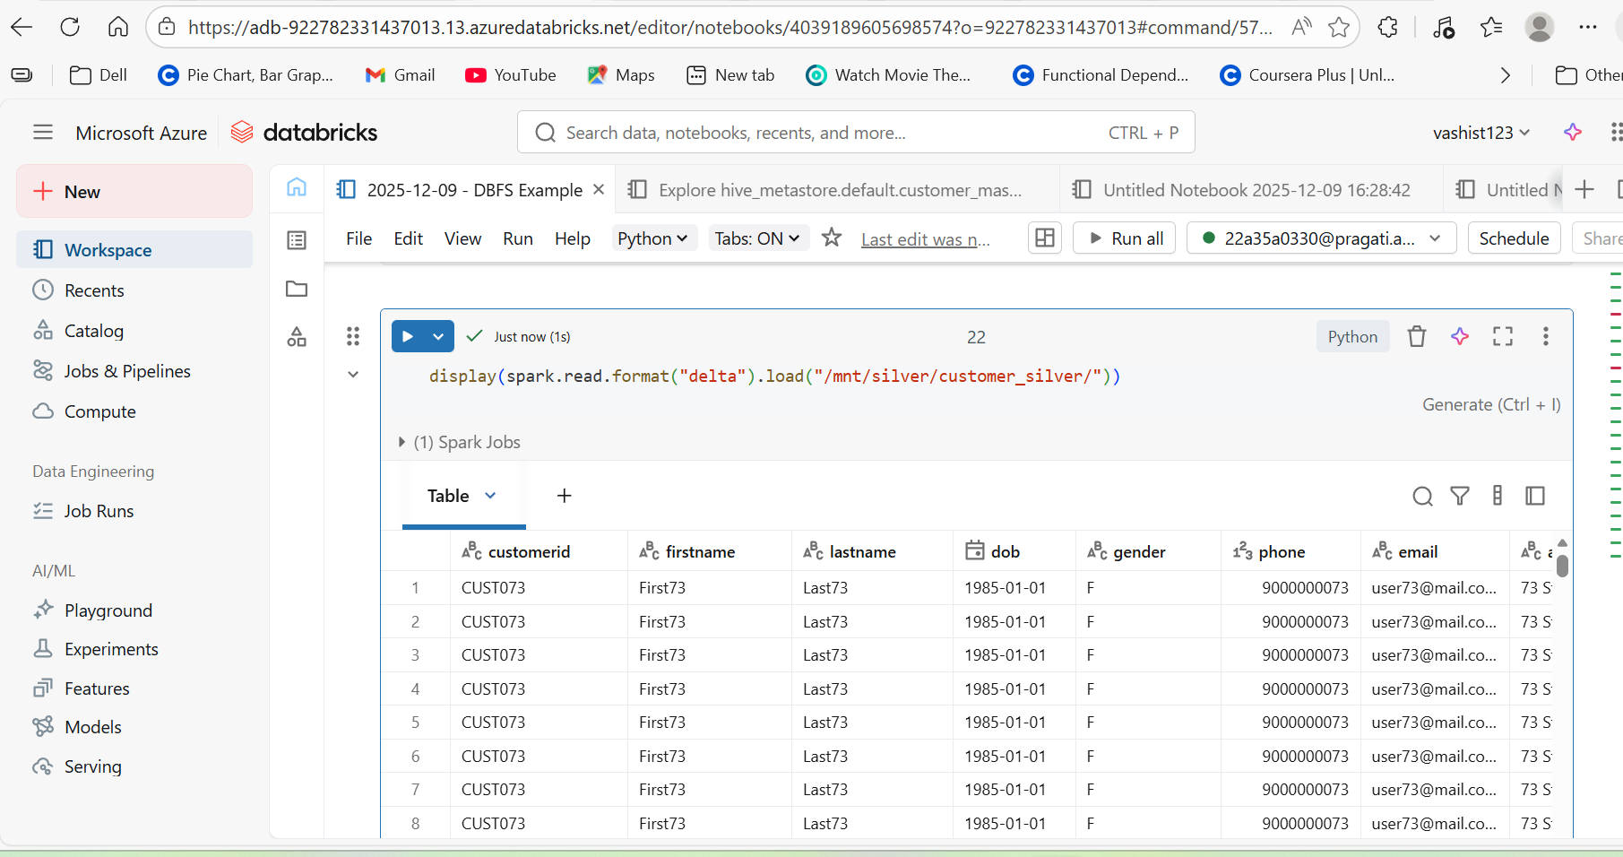
Figure :

Figure:
Figure : 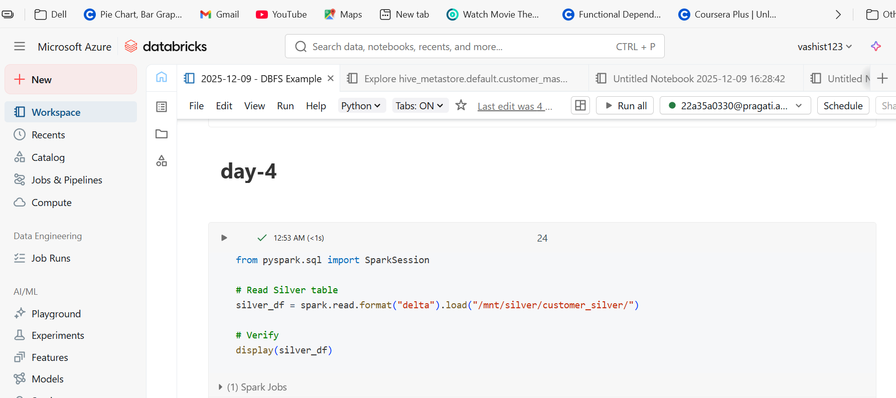
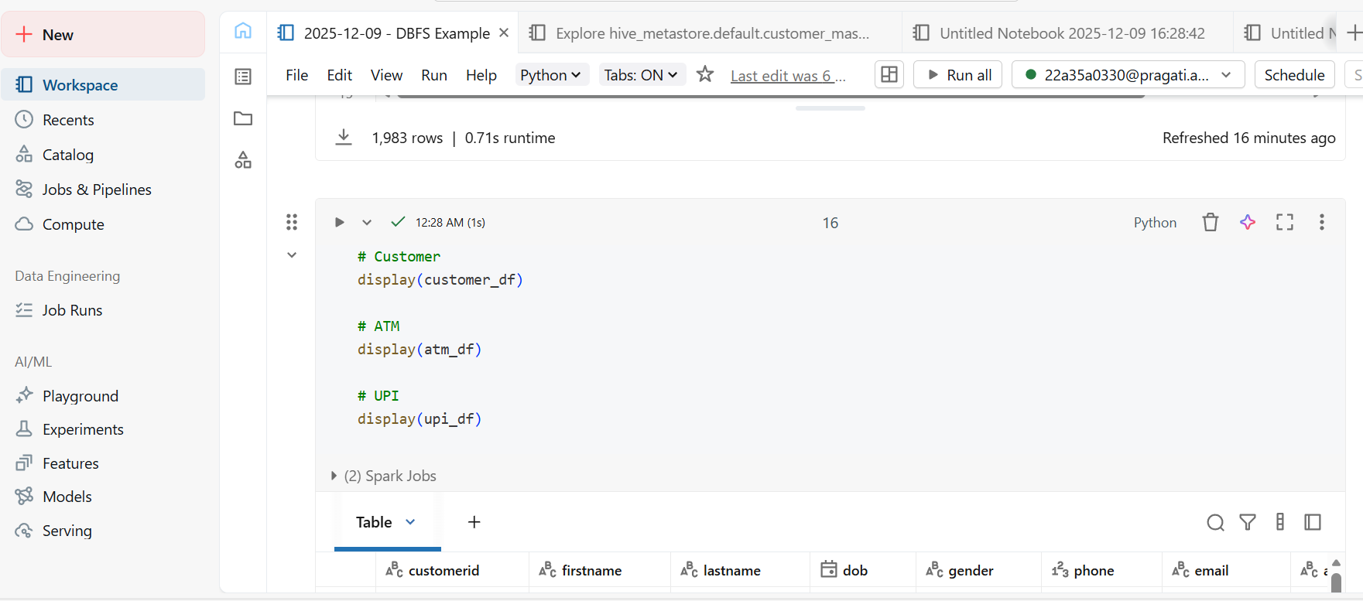
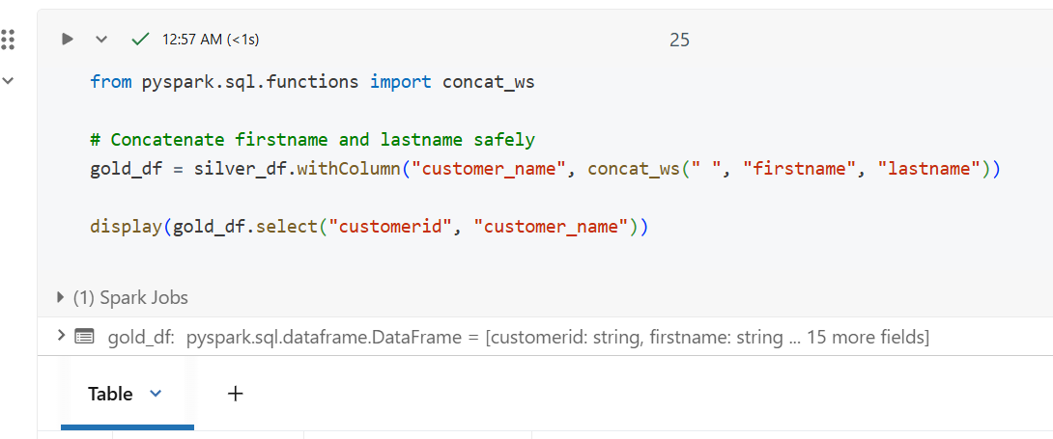
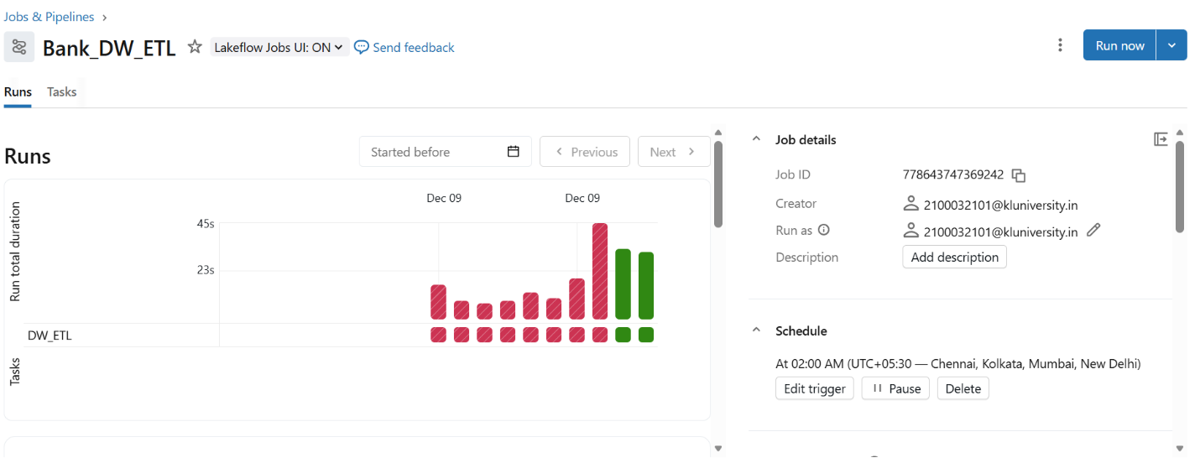
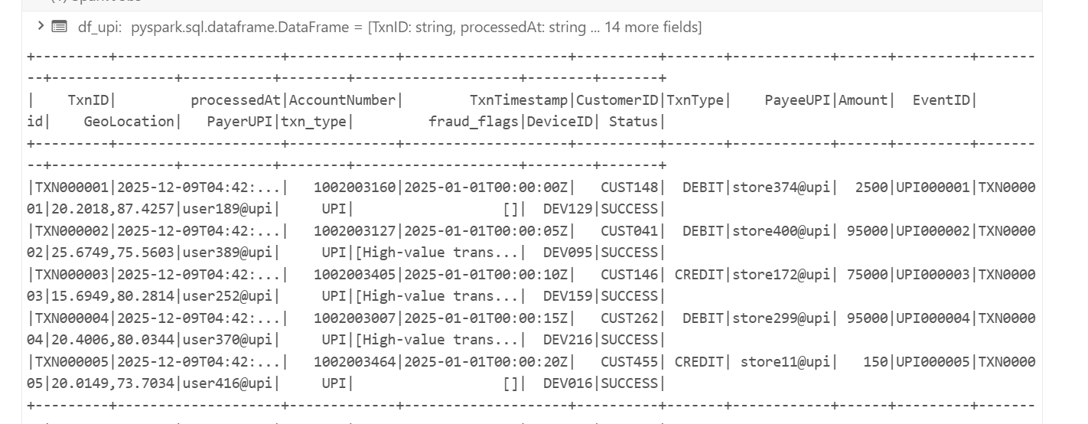
Figure:
Task-4 Day-4: Real-Time Fraud Detection, Security Hardening, and CI/CD Automation
- Create an Event Grid Subscription
- Build Fraud Alert Function (VS Code)
func new –
Select:
- Trigger → EventGridTrigger
- Name → FraudAlertFunction
We will have __init__.py and function.json file
Remmber you have to give connection string :
COSMOS_URL = "YOUR_URL"
COSMOS_KEY = "YOUR_KEY"
DB_NAME = "bankdb"
CONTAINER = "FraudAlerts"
Then Deploy Function .
If there is no error your Trigger will be upload on ur Function.app
Without fail .
CI/CD Pipeline (VS Code + GitHub+jenkins )
Create Jenkins Pipeline (CI/CD)
Before u have to push ur code to ur github.
Then u have to write ur code for ur jenkins ..

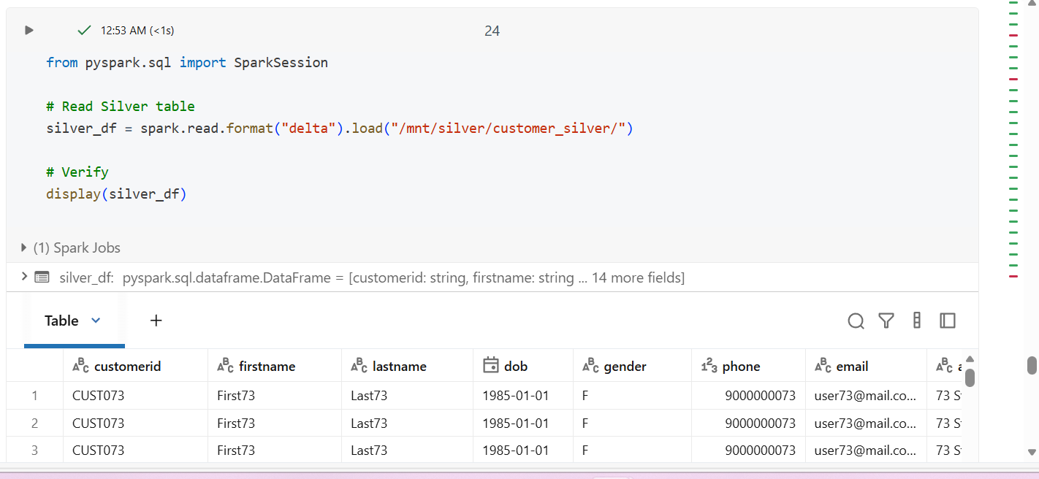
Even we can complete and fund fraud data in databrick also :
Figure:
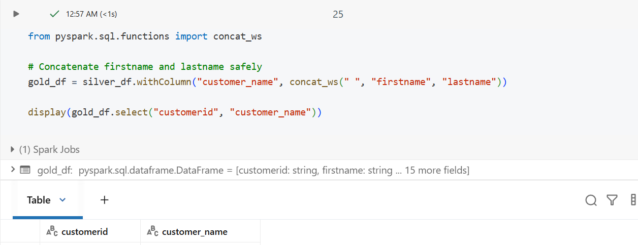

DAY-5 — Reporting, Customer 360 & Final Demo
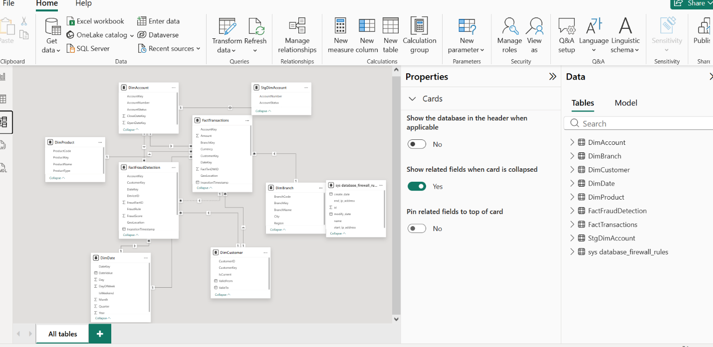
Power BI :
THIS SHOW MY TABLE HAVE ONE TO MANY REALTIONS
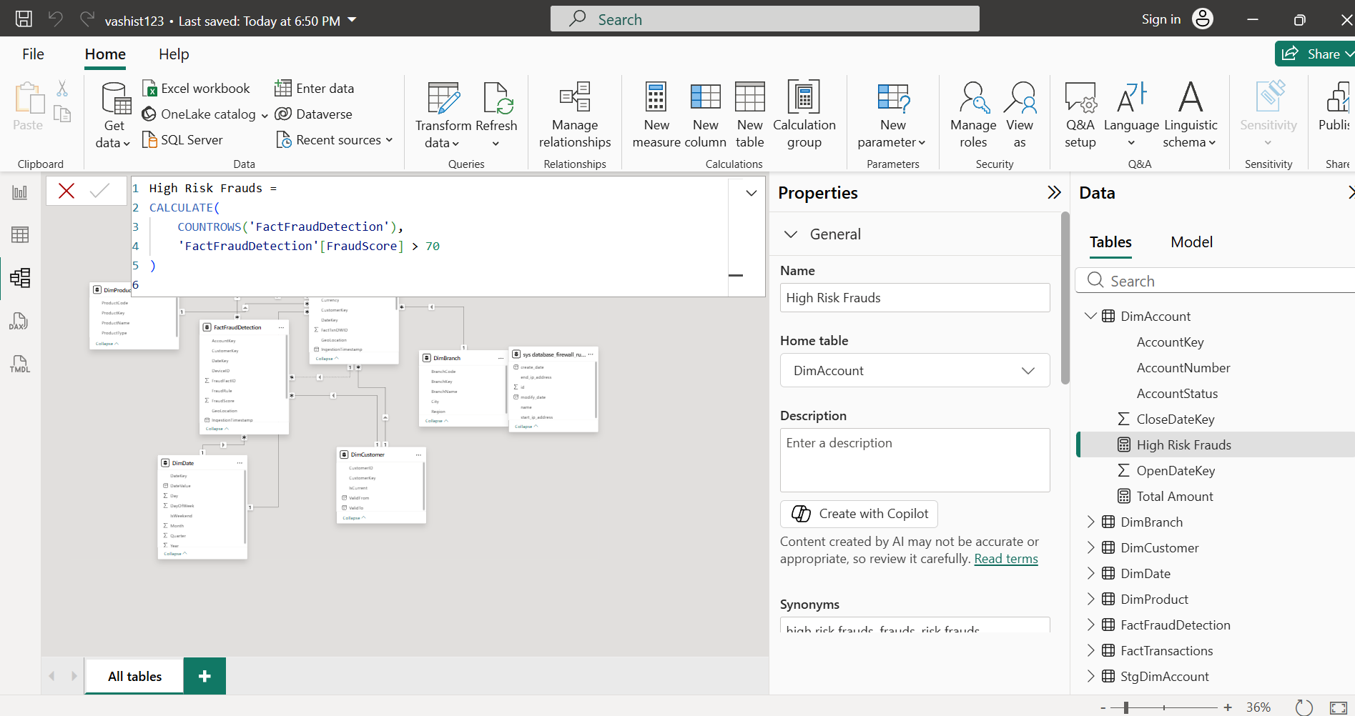
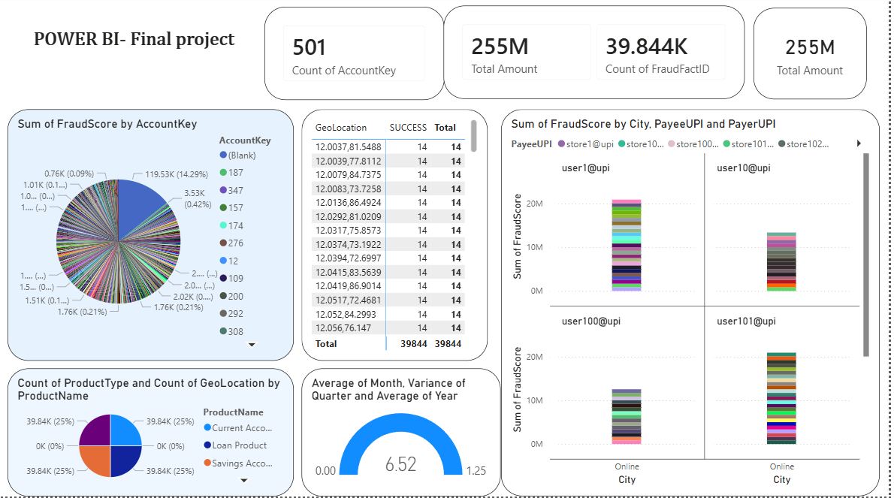
DASHBOARD :

This dashboard is a Fraud Analytics + Banking Performance dashboard built using data from:
- FactFraudDetection
- FactTransactions
- DimCustomer
- DimProduct
- DimBranch
- DimDate
It helps identify suspicious transactions, customer risk behaviour, and overall banking performance.
. Top-Level KPI Cards
(Seen at the top of the dashboard)
Count of AccountKey — 501
This shows the total number of unique accounts in the system.
It helps analysts understand the size of the customer base being monitored.
Total Amount — 255M
This represents the total transaction volume processed across all channels (ATM + UPI).
It shows the financial scale of activity.
Count of FraudFactID — 14
This indicates the number of fraud/suspicious events detected by the system.
It is an important KPI for the fraud management team.
Customer 360 Dashboard
he Customer 360 Dashboard provides a complete, unified view of a customer’s:
- Personal profile
- Account details
- Transaction behaviour
- Financial product usage
- Fraud & risk profile
- Channel preferences (UPI/ATM/Branch)
It is built by integrating data across Fact & Dimension tables:
- DimCustomer
- DimAccount
- DimBranch
- FactTransactions
- FactFraudDetection
- DimProduct
- DimDate

